DigitalXC
www.DigitalXC.com

Prepared On 25-05-2021

Data Subject Request Procedure
Contents
Introduction 3
Data subject request procedure overview 4
General Points 4
Procedure Flowchart 5
Data Subject Request Procedure Steps 6
Data Subject Request Received 6
Log Data Subject Request 6
Confirm Identity of Data Subject 6
Evaluate Validity of Request 6
Charge for Request 7
Compile Requested Information 7
Take Requested Action/Provide Requested Information 7
Close Data Subject Request 7
Types of data subject requests 8
The Right to Withdraw Consent 8
The Right to be Informed 8
The Right of Access 8
The Right to Rectification 9
The Right to Erasure 9
The Right to Restrict Processing 9
The Right to Data Portability 10
The Right to Object 10
Rights in Relation to Automated Decision Making and Profiling 10
Summary of Data Subject Rights by Lawful Basis of Processing 11

Introduction
This procedure is intended to be used when a data subject exercises one or more of the rights, they are granted under the European Union General Data Protection Regulation (GDPR).
Each of the rights involved has its own specific aspects and challenges to DigitalXC in complying with them and doing so within the required timescales. In general, a proactive approach will be taken that places as much control over personal data in the hands of the data subject as possible, with a minimum amount of intervention or involvement required on the part of DigitalXC. This may be achieved by providing online access to the personal data so that the data subject can verify and amend it as required.
However, in some cases there is a decision-making process to be followed by DigitalXC regarding whether a request will be allowed or not; where this is the case, the steps involved in these decisions are explained in this document.
This procedure should be considered in conjunction with the following related documents:
- Data Subject Request Register
- Data Protection Impact Assessment Process
- Records Retention and Protection Policy
- Data Protection Policy
- Legitimate Interest Assessment Procedure
- Privacy Notice Procedure

Data subject request procedure overview

General Points
The following general points apply to all of the requests described in this document and are based on Article 12 of the GDPR:
- Information shall be provided to the data subject in a concise, transparent, intelligible and easily accessible form, using clear and plain language, in particular for any information addressed specifically to a child
- Information may be provided in writing, or electronically or by other appropriate means
- The data subject may request the information orally (for example, over the telephone or face to face), as long as the identity of the data subject has been established
- We must act on a request from a data subject, unless we are unable to establish their identity
- We must provide information without undue delay and within a maximum of one month from the receipt of the request
- The response timescale may be extended by up to two further months for complex or a high volume of requests – the data subject must be informed of this within one month of the request, and the reasons for the delay given
- If a request is made via electronic form, the response should be via electronic means where possible, unless the data subject requests otherwise
- If it is decided that we will not comply with a request, we must inform the data subject without delay and at the latest within a month, stating the reason(s) and informing the data subject of their right to complain to the supervisory authority
- Generally, responses to requests will be made free of charge, unless they are “manifestly unfounded or excessive” (GDPR Article 12), in which case we will either charge a reasonable fee or refuse to action the request
- If there is doubt about a data subject’s identity, we may request further information to establish it
Please refer to the exact text of the GDPR if clarification of any of the above is required.
The procedure for responding to requests from data subjects is shown diagrammatically in Figure 1 and expanded on in the following sections. The specifics of each step in the procedure will vary according to the type of request involved – refer to the relevant section of this procedure for more detail. The following forms may be used in conjunction with this procedure:
- Data Subject Request Form

Procedure Flowchart
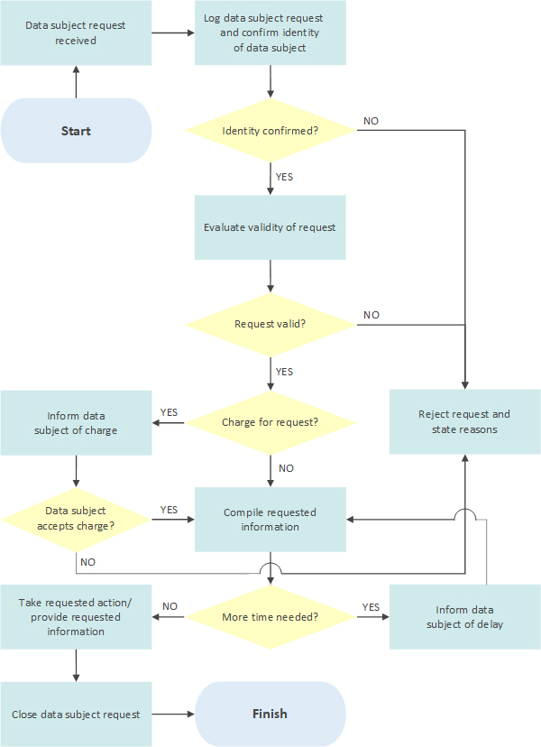
Figure 1: Data subject request procedure

Data Subject Request Procedure Steps
The steps depicted in the flowchart in Figure 1 are expanded upon in this section and further under the section addressing each specific type of request.

Data Subject Request Received
The data subject may submit a request via a number of methods, including electronically (via email, our website or via a social media channel), by letter or on the telephone. Requests may be received by any part of the organisation but should ideally be channelled through customer services. A Data Subject Request Form is available for this purpose, but this does not have to be used for the request to be valid, and there is no specific form of words that has to be used by the data subject.
A request may also be submitted on another person’s behalf, as long as they have been given authority to do so, and evidence of this must be provided. Care must be taken when accepting a request from a child, but this is permitted if they appear mature enough to understand the process. Otherwise, the child may authorise a parent, guardian or someone else they choose, to act on their behalf.

Log Data Subject Request
The fact that the request has been received is logged in the Data Subject Request Register and the date of the request recorded. The information to be recorded will depend upon the nature of the request (for example, access to information, consent withdrawal) and a check must be made that all of the information required to be able to comply with the specific type of request is provided and captured (for example the processing for which consent is being withdrawn).

Confirm Identity of Data Subject
The identity of the data subject must be confirmed via an approved method. More information may be requested to confirm identity if required, and the allowed timescale for responding to a request does not start until the identity of the requester has been satisfactorily established.
If the identity of the data subject cannot be confirmed, the request is rejected and the reason for this communicated to the data subject, along with further information about their right to complain to the relevant supervisory authority.

Evaluate Validity of Request
The test of whether the request is “manifestly unfounded or excessive” must be applied. In general terms, a request may be considered manifestly unfounded if it appears malicious in its intention, for example to cause disruption or harm to an individual or the organisation, or if there is no genuine desire on the part of the data subject to exercise their rights. A manifestly excessive request is one which may be clearly judged to be unreasonable in the context of the request and the relationship between the organisation and the data subject, for example if it is a repeat of a recently submitted request for very similar information, or if the resources required to fulfil the request are excessive.
In those circumstances where a request is judged to meet these criteria, it must be escalated to management for review and, if confirmed, the reasons for classifying the request as such clearly recorded in the Data Subject Request Register.
In the case of requests for rectification, erasure, restriction of, or objection to, processing, a decision is also taken about whether the request is reasonable and lawful. If not, the request is rejected, and the data subject informed of the decision and their right to complain to the supervisory authority.

Charge for Request
For requests that are identified as manifestly unfounded or excessive, a decision must be taken whether to reject the request outright or to apply a charge to it. The charge must be paid by the data subject if they still want the request to be processed. The GDPR allows the organisation to “charge a reasonable fee taking into account the administrative costs of providing the information or communication or taking the action requested” (GDPR Article 12 (5a)). In this event, the method of calculation of the fee will be documented.
If a charge is applied, the data subject is informed of the charge and has an opportunity to decide whether to proceed. If the data subject decides not to proceed, the request is rejected, and the reasons communicated.

Compile Requested Information
The relevant information is compiled according to the type of request. The organisation must make reasonable efforts to comply with the request, but there may be a limit to the amount of resource that it is fair to apply to it. This step may involve planning how the requested action, for example, erasure or restriction of processing, will be achieved.
In the event that some or all of the requested information involves other identifiable individuals, then their consent may be required in order for it to be disclosed. If this is not available, a balanced decision must be taken regarding whether it is reasonable to disclose the information without their consent. It may be decided to provide some, but not all of the requested information in some circumstances. Techniques such as redaction may also be used where appropriate to remove information about other identifiable individuals.
A maximum of one month is permitted to comply; if the request will take longer than that then a maximum of two further months are allowed and the data subject must be informed of the delay and the reasons for it within one month of the request being submitted. Time extensions and the reasons for them must be recorded in the Data Subject Request Register.

Take Requested Action/Provide Requested Information
The requested action is carried out (see the following sections of this document for details) or, for access requests, the information requested is provided to the data subject, and they are informed of the completion of the request.

Close Data Subject Request
The fact that the request has been completed is logged in the Data Subject Request Register, together with the date of closure.

Types of data subject requests

The Right to Withdraw Consent
The data subject has the right to withdraw consent where the basis for processing of their personal data is that of consent (that is, the processing is not based on a different justification allowed by the GDPR such as contractual or legal obligation).
Before excluding the data subject’s personal data from processing, it must be confirmed that consent is indeed the basis of the processing. If not, then the request may be rejected on the grounds that the processing does not require the data subject’s consent. Otherwise, the request should be allowed.
In many cases, the giving and withdrawal of consent will be available electronically, that is, online, and a manual procedure will not be required.
Where consent involves a child (defined by the GDPR as age 16+ unless changed by law in individual member states) the giving or withdrawal of consent must be authorised by the holder of parental responsibility over the child.

The Right to be Informed
At the point where personal data are collected from the data subject or obtained from another source, there is a requirement to inform the data subject about our use of that data and their rights over it. Compliance with this right is addressed in a separate document, Privacy Notice Procedure, which describes the information that must be provided and sets out how and when this must be achieved.

The Right of Access
A data subject has the right to ask DigitalXC whether we process data about them, to have access to that data and in addition the following information:
- The purposes of the processing
- The categories of the personal data concerned
- The recipients, or categories of recipients, of the data, if any, in particular any third countries or international organisations
- The length of time that the personal data be stored for (or the criteria used to determine that period)
- The data subject’s rights to rectification or erasure of their personal data and restriction of, or objection to, its processing
- The data subject’s right to lodge a complaint with a supervisory authority
- Information about the source of the data, if not directly from the data subject
- Whether the personal data will be subject to automated processing, including profiling and, if so, the logic and potential consequences involved
- Where the data are transferred to a third country or international organisation, information about the safeguards that apply
In most cases, the decision-making process for such requests will be straightforward unless it is judged that the request is manifestly unfounded or excessive. The compilation of the information is likely to require the input of the data owner.

The Right to Rectification
Where personal data is inaccurate, the data subject has the right to request that it be corrected, and incomplete personal data completed based on information they may provide.
Where necessary, DigitalXC will take steps to validate the information provided by the data subject to ensure that it is accurate before amending it.

The Right to Erasure
Also known as “the right to be forgotten”, the data subject has the right to require DigitalXC to erase personal data about them without undue delay where one of the following applies:
- The personal data are no longer necessary for the purpose for which they were collected
- The data subject withdraws consent and there is no other legal ground for processing
- The data subject objects to the processing of the personal data
- The personal data have been unlawfully processed
- For compliance reasons, that is, to meet the legal obligations of DigitalXC
- Where the personal data was relevant to the data subject as a child
Reasonable efforts must be made to ensure erasure where the personal data has been made public.
DigitalXC will need to decide on each case of such requests as to whether the request can or should be declined for one of the following reasons:
- Right of freedom of expression and information
- Compliance with a legal obligation
- Public interest in the area of public health
- To protect archiving purposes in the public interest
- The personal data is relevant to a legal claim
It is likely that such decisions will require the involvement of the DigitalXC Data Protection Officer (if appointed) and in some cases senior management.

The Right to Restrict Processing
The data subject can exercise the right to a restriction of processing of their personal data in one of the following circumstances:
- Where the data subject contests the accuracy of the data, until we have been able to verify its accuracy
- As an alternative to erasure in the circumstances that the processing is unlawful
- Where the data subject needs the data for legal claims, but it is no longer required by us
- Whilst a decision on an objection to processing is pending
DigitalXC will need to decide on each case of such requests as to whether the request should be allowed. It is likely that such decisions will require the involvement of the DigitalXC Data Protection Officer and in some cases senior management.
Where a restriction of processing is in place, the data may be stored but not processed without the data subject’s consent, unless for legal reasons (in which case the data subject must be informed). Other organisations who may process the data on our behalf must also be informed of the restriction.

The Right to Data Portability
The data subject has the right to request that their personal data be provided to them in a “structured, commonly-used and machine-readable format” (GDPR Article 20) and to transfer that data to another party, for example, service provider. This applies to personal data for which processing is based on the data subject’s consent and the processing carried out by automated means.
Where feasible, the data subject can also request that the personal data be transferred directly from our systems to those of another provider.
For services that come under this category, little decision-making is required for each case and it is highly desirable that this process is automated in its execution.

The Right to Object
The data subject has the right to object to processing that is based on the following legal justifications:
- For the performance of a task carried out in the public interest or in the exercise of official authority vested in the controller
- For the purposes of the legitimate interests of the controller
Once an objection has been made, DigitalXC must justify the grounds on which the processing is based and suspend processing until this is done. Where the personal data is used for direct marketing, we have no choice but to no longer process the data.

Rights in Relation to Automated Decision Making and Profiling
The data subject has the right to not be the subject of automated decision-making where the decision has a significant effect on them and can insist on human intervention where appropriate. The data subject also has the right to express their point of view and contest decisions.
There are exceptions to this right, which are if the decision:
- Is necessary for a contract
- Is authorised by law
- Is based on the data subject’s explicit consent
In assessing these types of requests, a judgement needs to be made about whether the above exceptions apply in the case in question.

Summary of Data Subject Rights by Lawful Basis of Processing
The following table shows which rights of the data subject are relevant to each basis of lawful processing. It should be used as a general guide only, as the specific circumstances may affect the validity of the request.
RIGHT OF  THE DATA SUBJECT | BASIS OF LAWFUL PROCESSING
 | CONSENT | CONTRACTUAL | LEGAL OBLIGATION | VITAL INTERESTS | PUBLIC INTEREST | LEGITIMATE INTEREST
Withdraw consent | YES | NO | NO | NO | NO | NO
Be informed | YES | YES | YES | YES | YES | YES
Access | YES | YES | YES | YES | YES | YES
Rectification | YES | YES | YES | YES | YES | YES
Erasure | YES | NO | NO | NO | NO | YES
Restrict processing | YES | YES | YES | YES | YES | YES
Data portability | YES | YES | NO | NO | NO | NO
Object | N/A | NO | NO | NO | YES | YES
Automated decision making and profiling | N/A | NO | NO | YES | YES | YES
Table 1: Applicable rights based on lawful basis of processing
Note: All the above assume that:
- the personal data are being lawfully processed
- the personal data are necessary in relation to the purposes for which they were collected or otherwise processed
If this is not the case, then further investigation must be made regarding the validity of the request.

--End of Document--

